EEL 6878 Homework 4
  - Dylan D’Silva

Question 1.
The plot below shows the Graph Fourier Transform of the Heat filtered random signals.
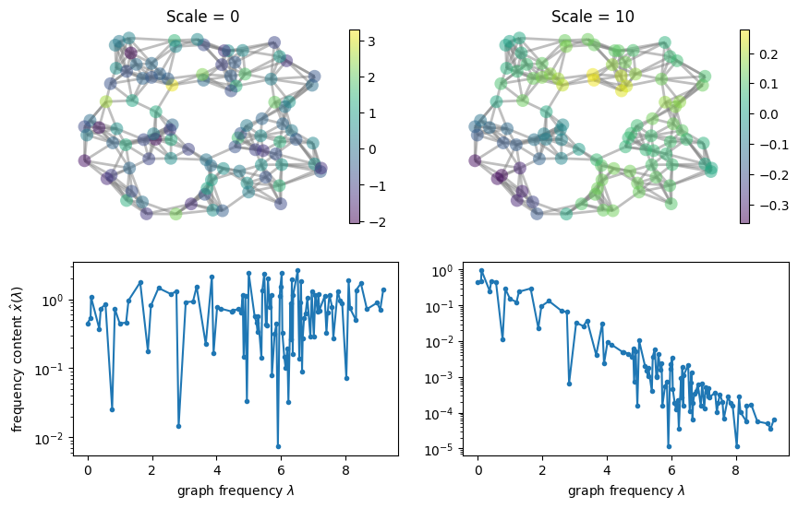
Figure 1: GFT of Heat Filtered Random Graph Signals
The graph signal generated by applying a Heat filter bank with $scale=10$ is a low-pass signal. Only low frequencies retain their spectral power, while higher frequencies fall off exponentially.
When applying the Heat kernel with $scale=0$ to the random signal, the resulting signal had a smoothness of $580.9577$. For the case when $scale=10$, the resulting signal had a smoothness of 0.7838.
The higher scale filter produced a significantly smoother signal, which can be observed in the top row of Figure 1. Transitions between node values at $scale=10$ appear much more gradual than for $scale=0$. Higher frequencies present in the signal are responsible for more drastic changes in the values of connected nodes. This allows for a rougher signal with more variation. Attenuating the signal at these frequencies removes most of the potential for large changes between nodes. A Heat filter with $scale=10$ does more to eliminate higher frequencies in the signal, as seen in the second row of Figure 1. Higher frequency content remains present in the filtered signal for $scale=0$ while being attenuated by orders of magnitude when $scale=10$.

Question 2.

Part 1) Loaded Graphs and Their Eigenvalues
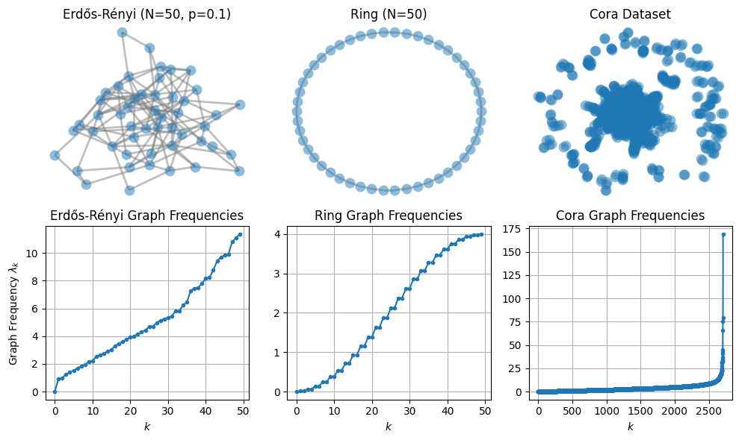
Figure 2: Generated or Loaded Graphs and Spectral Content

Part 2) Graph Eigenvectors

Erdos
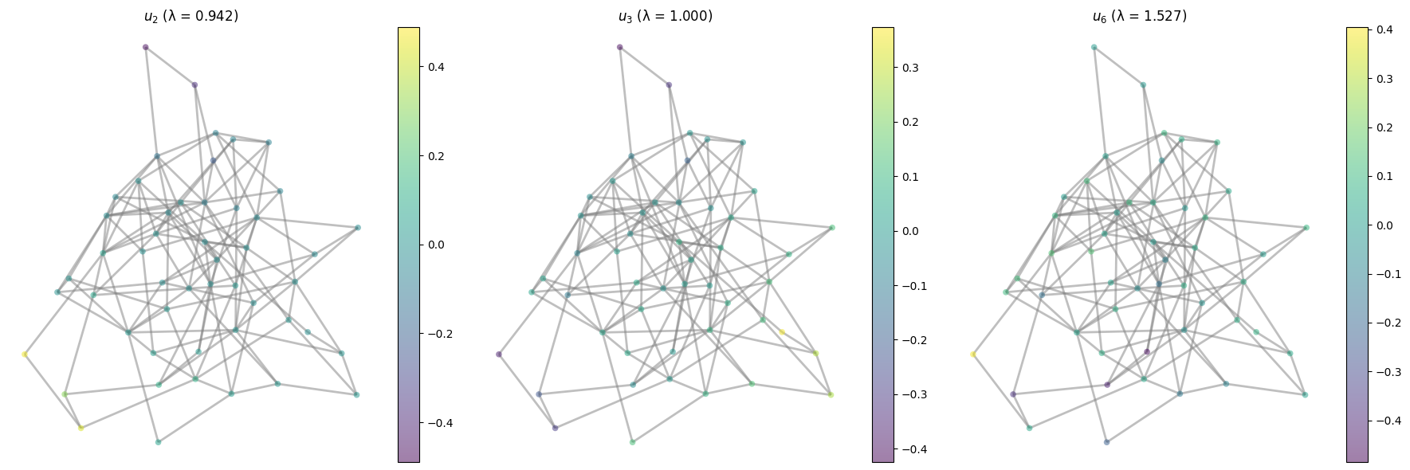

Ring
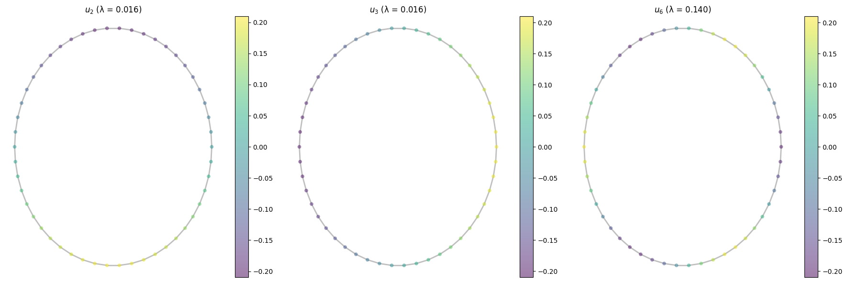

Cora
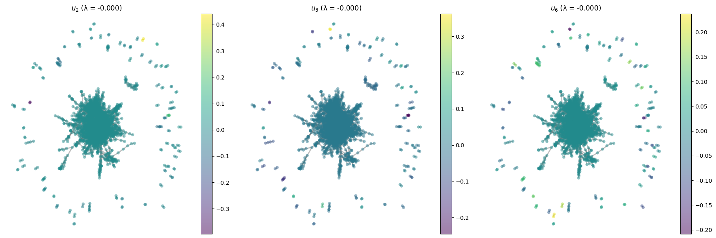

Ring Denoising

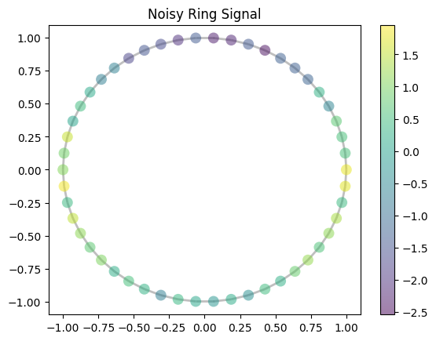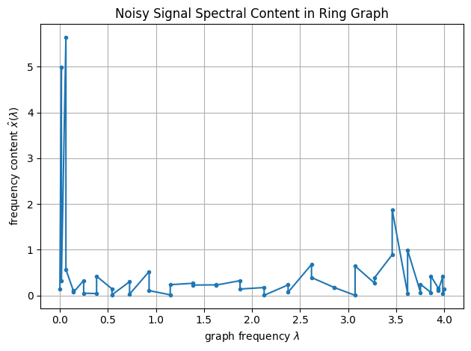

Denoised Signal
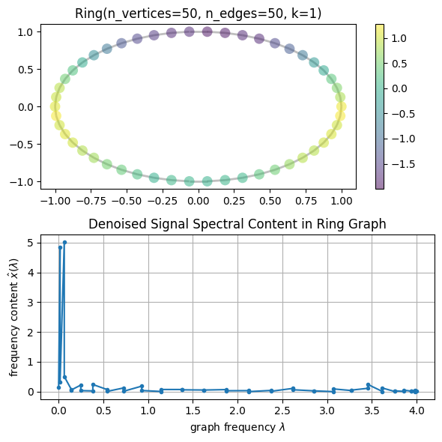

Question 3.

Training Loss
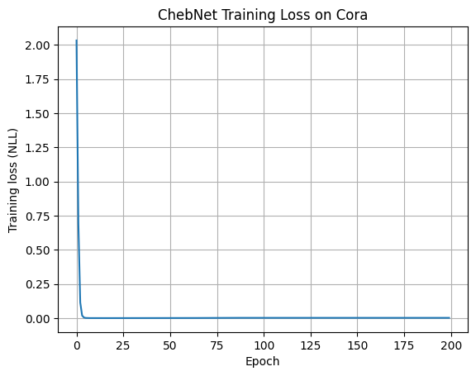

Model Evaluations
